**Incarnation Parish**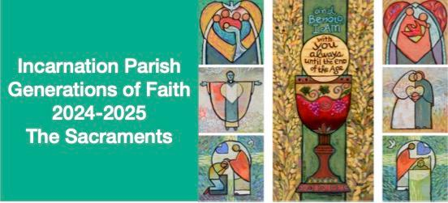

**Generations of Faith Registration**

**2024-2025**

**The Sacraments**

**Household Name:**

**Address:**

**Phone:**

**E-Mail:**

**Emergency Contact** (if registering children):

**Household Members:**

Please list all who will participate~~for children, indicate grade as of September 2024. Please note this is a family-based program; children Grades 8 and under **MUST** register with an adult.

Name:                                                         Adult/Youth (circle one)

Name:                                                          Adult/Youth

Name                                                  Adult/Youth                   Grade:_____

Name                                                  Adult/Youth                   Grade:_____

Name                                                  Adult/Youth                   Grade:_____

Name                                                  Adult/Youth                   Grade:_____

Fees: $175 /Family,  $75/Individual, checks payable to Incarnation Parish.  Fee includes all materials for learning sessions, textbooks and at-home resources for families, and adult faith formation materials.

Please return completed form to Faith Formation Office, 429 Upham Street, Melrose, or via email to annlahiff7@aol.com, or via mail, or by the collection basket at Sunday Mass.